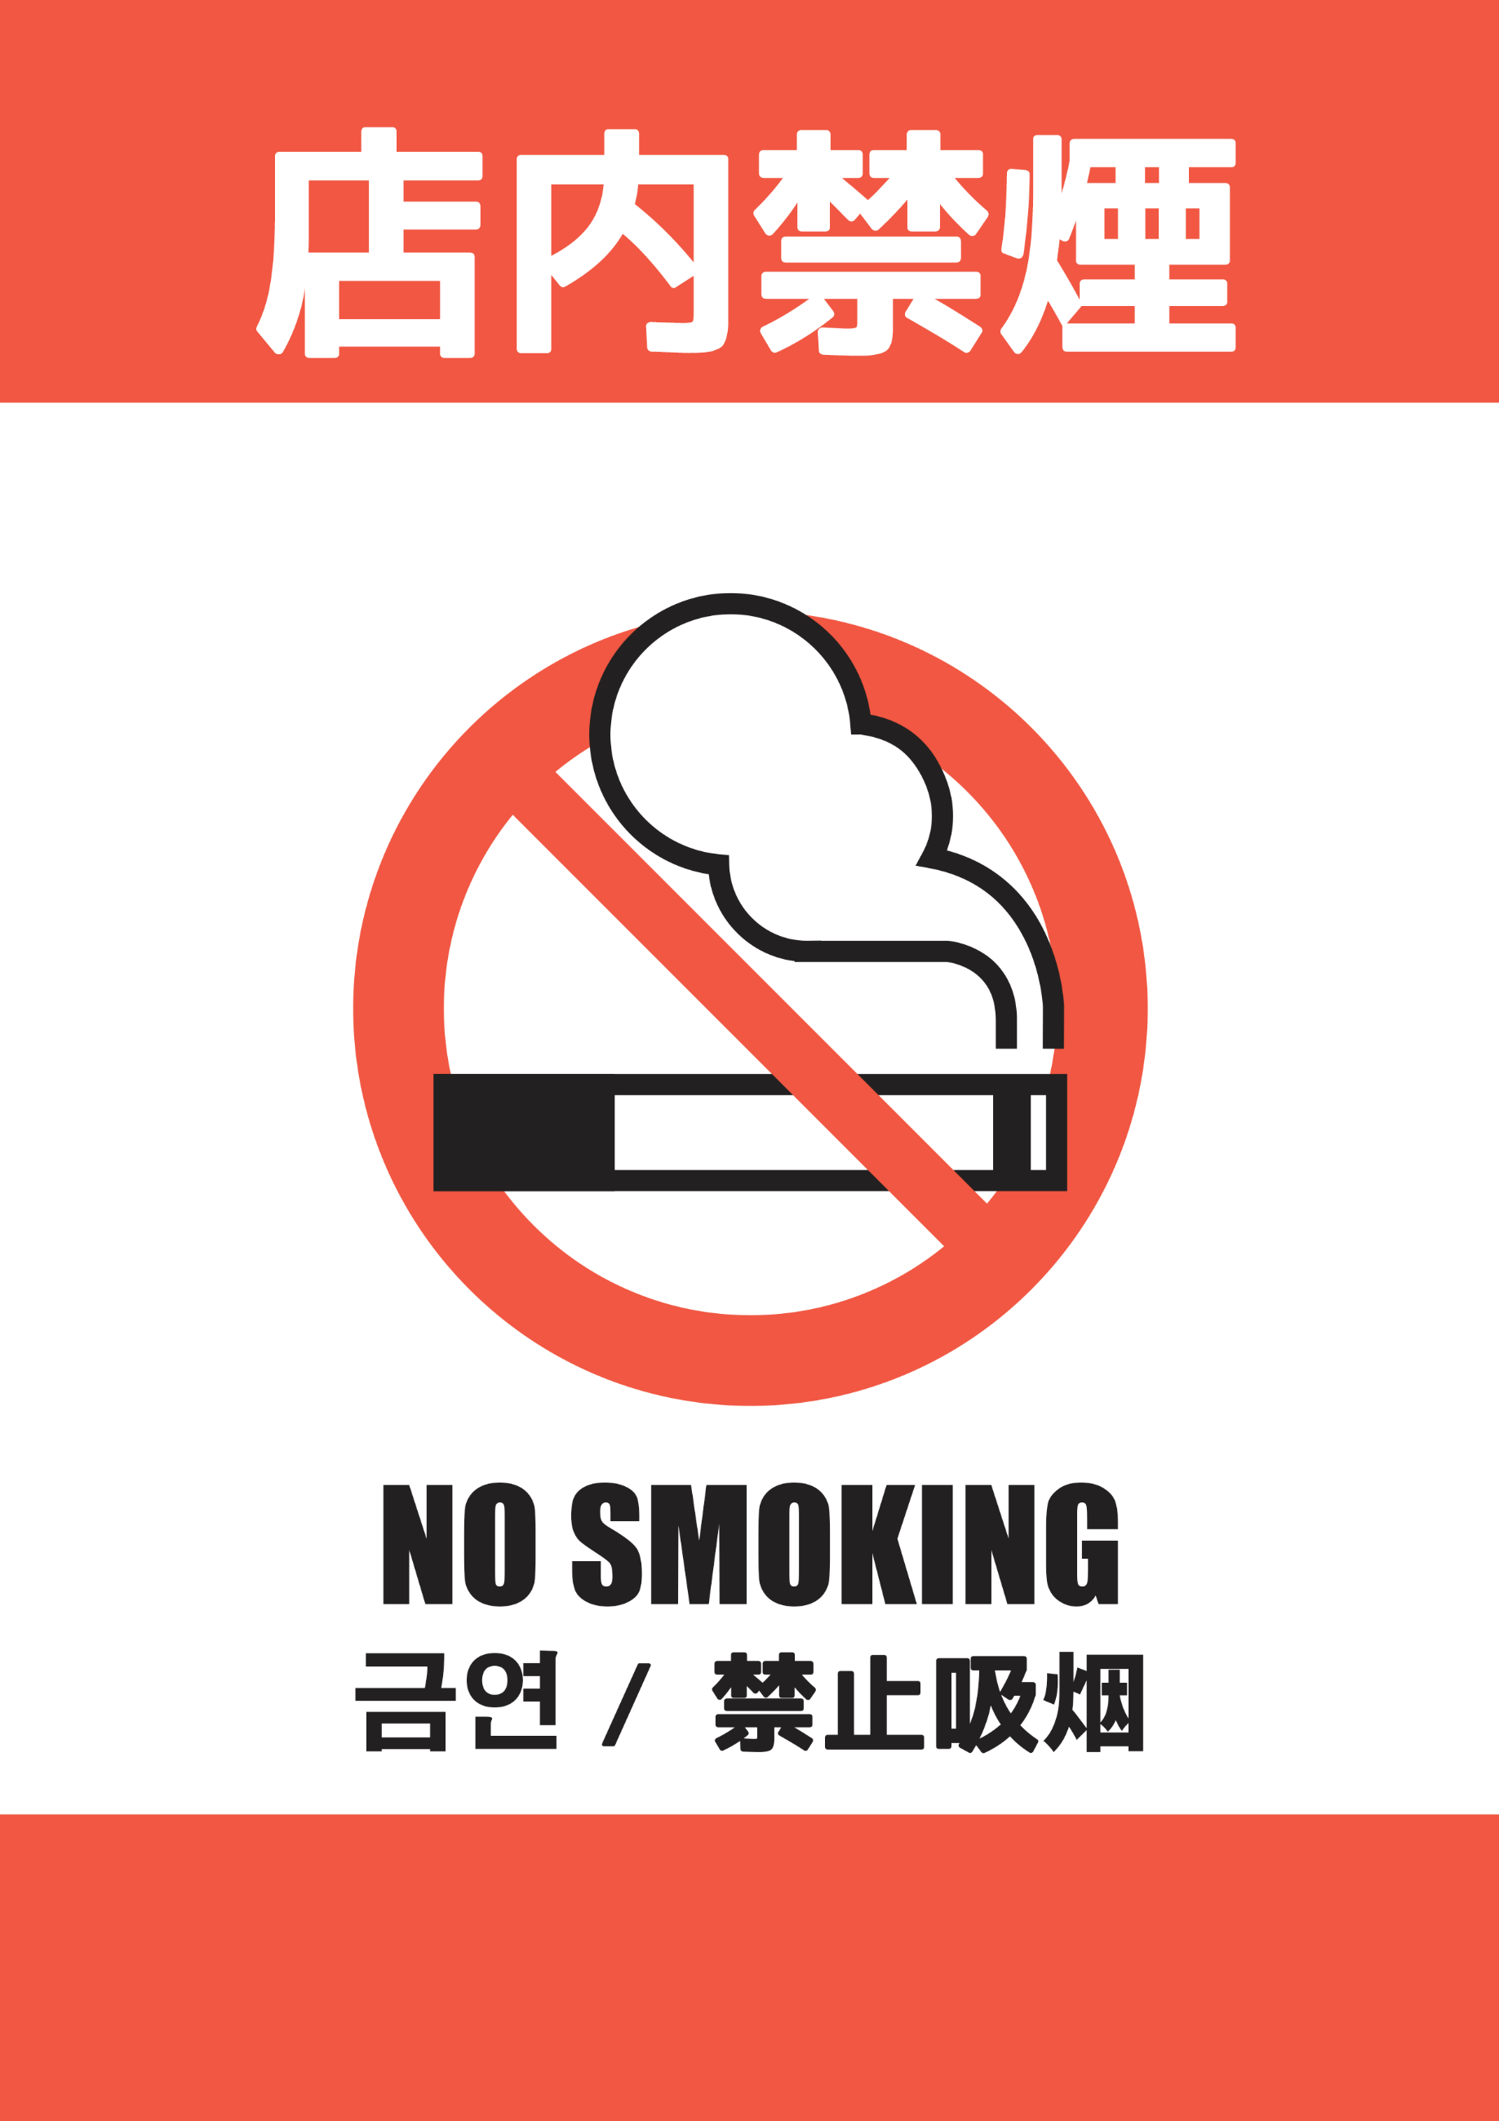

**店内での喫煙はご遠慮ください**

**※加熱式たばこ、電子たばこも含みます**

**No Smoking Including E-Cigarette**